Accessing the CFT2 Virtual Machine

## To log onto the Virtual Machine from a Windows desktop…

1. Launch Remote Desktop Connection. You can do this by either opening the Start button, then find the Accessories Folder and clicking on the Remote Desktop Connection icon, or you can click the Start button, typing **mstsc** in the “search programs and files” box, then hitting Return.
2. Copy and paste (or type) the following string into the Computer field:  
   **ec2-54-221-212-148.compute-1.amazonaws.com**
3. If you see a line that says, “you will be asked for credentials when you connect”, you can ignore the contents of the Username field for the moment. If you don’t see that, then click Options, and check the Always ask for credentials box. Save, then Click Connect.
4. Click Use another account. Your username is **kdausin**. Your first-time / one-time password is **Changeme123!** Click OK. Follow the instructions for entering a new personal password.
5. That should do it! You should get a desktop with a couple of icons on it, including the icon to launch the Bench. If you wish to switch back to your host machine, hover your mouse at the top of the screen and a drop-tab will appear. This contains controls to minimize or “window-ize” your remote session.
6. You should be able to cut/paste from host to remote and vice-versa by default. Your printers should also work. Other things may not work. To play with “bridging” settings, log off the remote, restart Remote Desktop Connection and click the Options button. You can adjust the Display and Local Resources options as you see fit.

If you have any problems, contact Bob O’Brien at [bobrien@provensecure.com](mailto:bobrien@provensecure.com).

Configuring Systems for Testing

In order to successfully run the CFT2 Bench application on the Virtual Machine, you’ll need to do a couple of things on your client/desktop machine, and you’ll need to do one or two user-specific things on your Server Account.

**Using Your Plug & Play Devices on the Server**

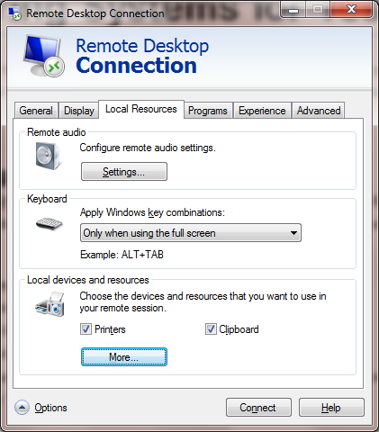If you have a true Plug & Play camera or microphone, the Windows Server 2008 R2 operating system on the AWS VM may be able to “see” it without you doing anything. To see if this will work for you, do the following:

1. Start Remote Desktop, but don’t actually log in.
2. Click the “Options” button to see the full view.
3. Click the “Local Resources” tab.
4. Under local devices and drives, click the “More” button
5. If your camera and/or microphone appear, in the list, make sure they are checked. (Make sure you expand the “Other supported…” part of the tree.)
6. Once you’ve got your devices selected, go back to the General tab and log onto the remote server
7. To verify that your devices are visible, open Control Panel and select Device Manager. See if you can find your camera. Then go back to Control Panel and select Sound. See if your microphone appears as a recording device. (While you are here, you can fix your Sound Profile as described later in this document.)

If your camera and microphone are not on this list, you’ll need to follow the instructions in one or both of the sections below.

**Configuring Your Client Camera to Bridge to the Server**

If your camera doesn’t bridge – and if you have a Logitech Camera, this will be the case – you’ll need to use the software approach to get your camera recognized…

1. Go to this website: <http://www.fabulatech.com/webcam-for-remote-desktop-download.html>
2. Click the Workstation button for either Windows or Linux depending on what your local desktop/laptop is running.
3. Download and install the software. It is free. There’s no configuration or further setup required on the client.
4. Log onto the Remote Server, and check your System Tray in the bottom right corner. You should see an icon that, when hovered over, identifies itself as “Webcam for Remote Desktop”. If you click on this, you should see your camera in a list. “Auto-detect” is probably selected; you can leave this, or you can manually choose a camera.
5. When you use the Bench application, you’ll select the **FabulaTech Virtual Camera** as the device you wish to use.

**Configuring Your Client Microphone to Bridge to the Server**

If your microphone doesn’t bridge – and if you have a Logitech Microphone, this will be the case – you’ll need to use the software approach to get your camera recognized…

1. Go to this website: <http://www.fabulatech.com/sound-over-rdp-download.html>
2. Click the Workstation button for either Windows or Linux depending on what your local desktop/laptop is running.
3. Download and install the software. It is free. There’s no configuration or further setup required on the client.
4. Log onto the Remote Server, open the Control Panel and select Sound. You should see FabulaTech Virtual Speakers for playback and FabulaTech Virtual Microphone for recording.

When you use the Bench application, you’ll select the **Unknown** microphone as the device you wish to use.